Eduardo Gallego Chillón - 2º DAW

ies francisco ayala  (Granada)

**FIREBASE INSTALLATION GUIDE**



**Index**

**1.** **Installation** 2

**2.** **Project creation** 2

**3.** **Configuration** 4

**4.** **Add project to a web application** 6

**5.** **Database creation** 8

**6.** **Test performance** 11

**7.** **Start the server** 11

# **Installation**

First, we install Firebase with the following command:

**sudo npm i -g firebase-tools**

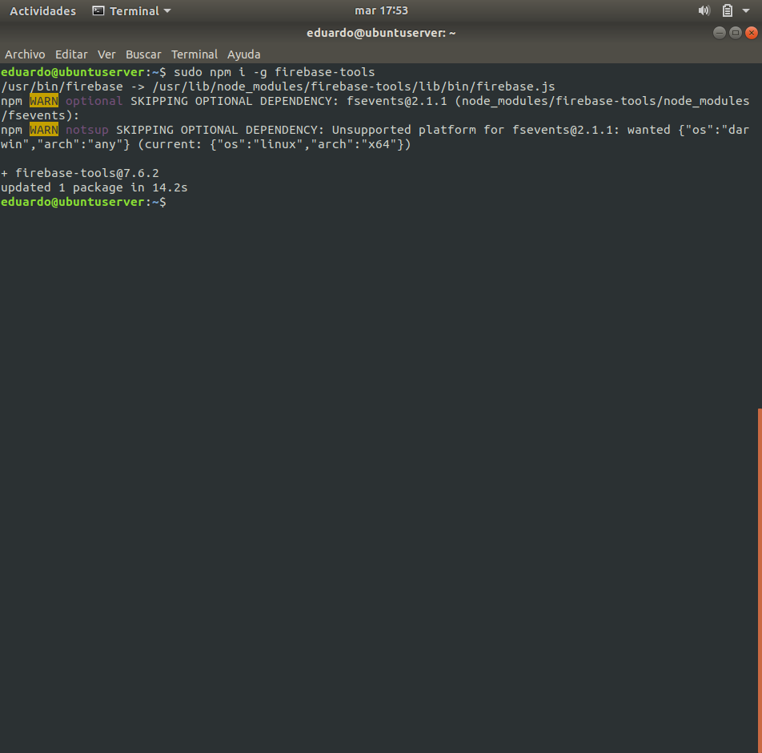

Fig. 1 - Firebase installation

# **Project creation**

* Open this URL in a web browser for open the Firebase start page, and click on the ***Comenzar*** button:

[**https://firebase.google.com/**](https://firebase.google.com/)

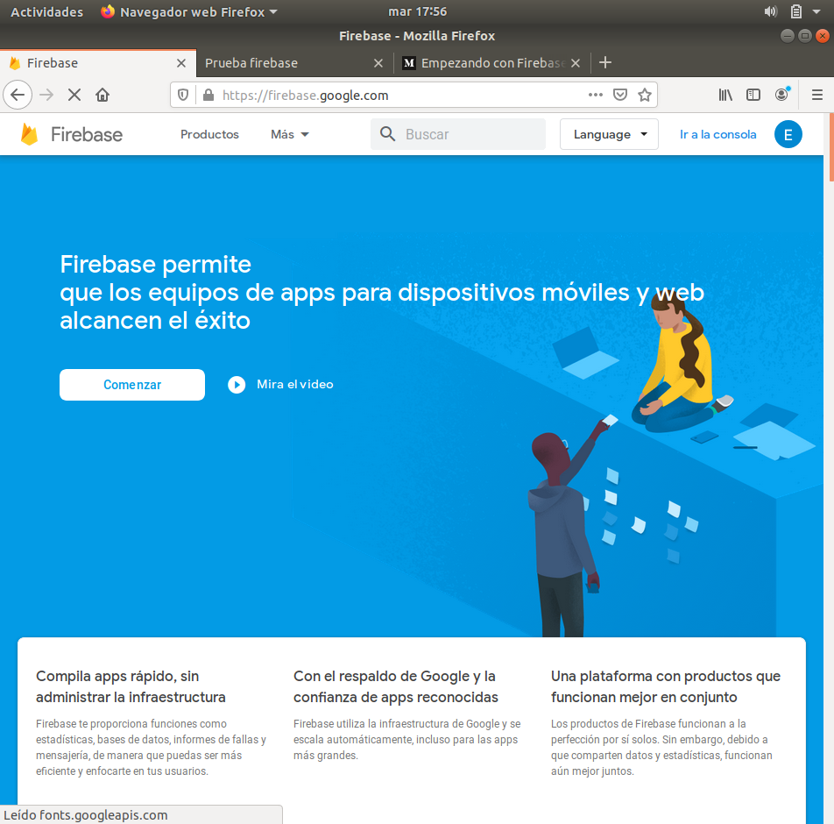

Fig. 2 - Firebase start page

* Then, click on ***Crear Proyecto*** for start to create a project.

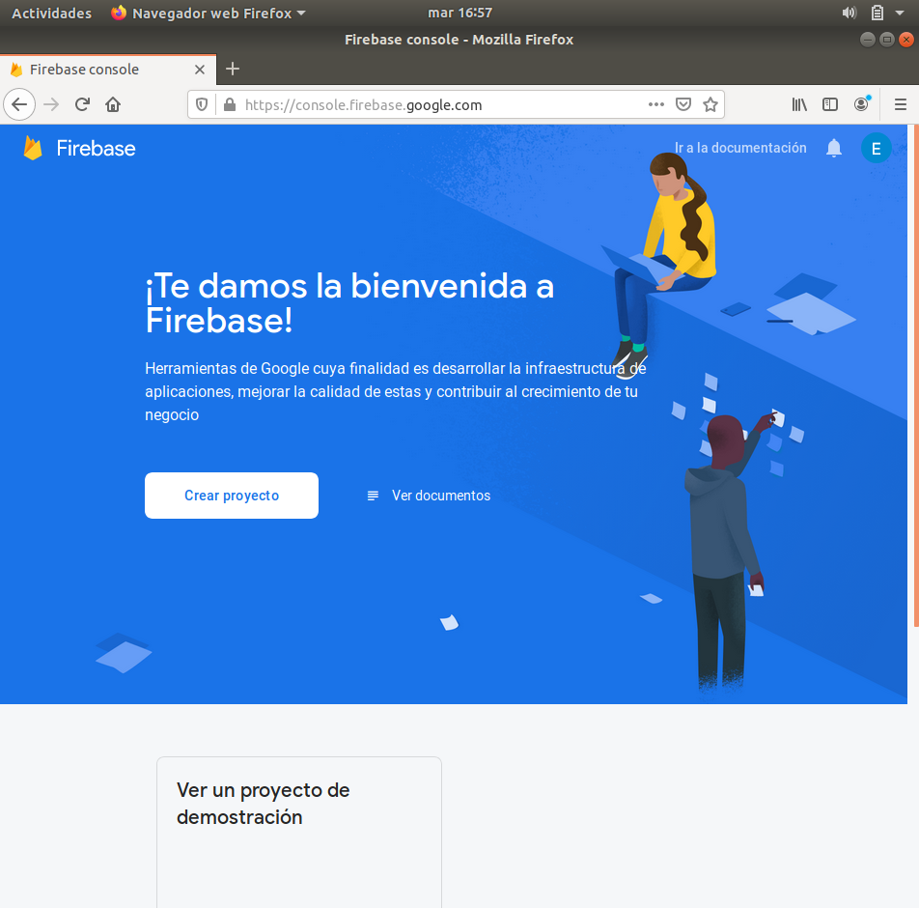

Fig. 3 - Firebase project creation

* Next, we give a name for the project and click on ***Continuar*** button.

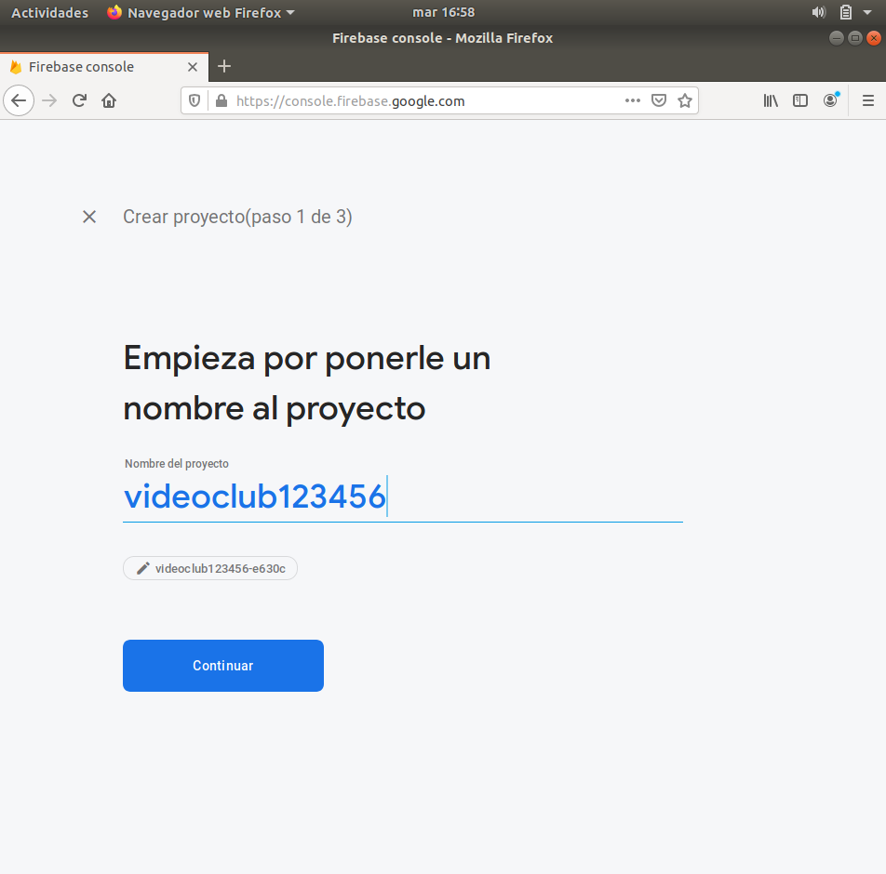

Fig. 4 - Project name input

* Click again on ***Continuar*** for allow Google Analytics on the project.

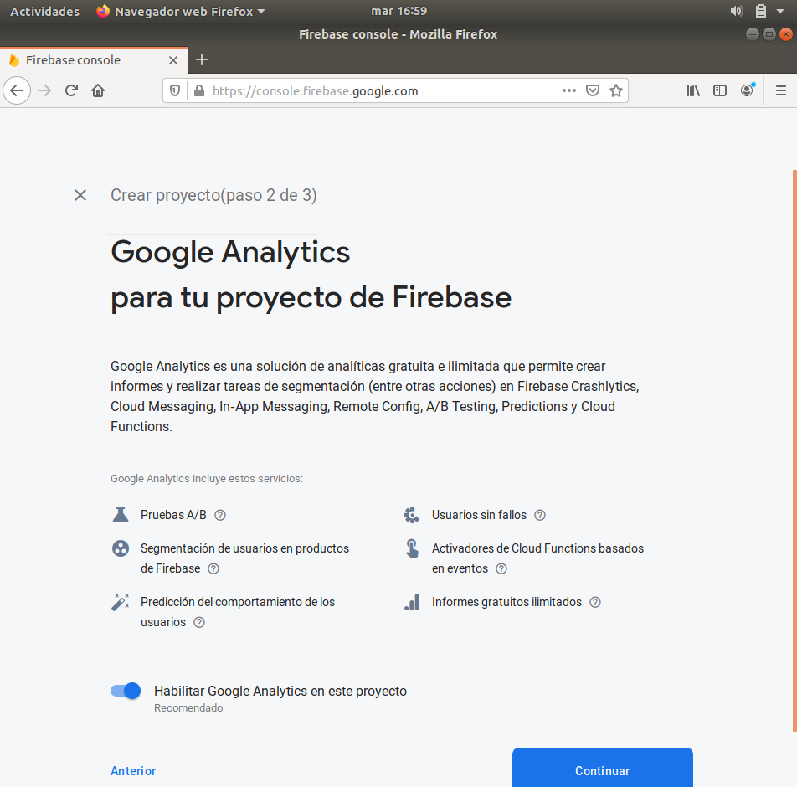

Fig. 5 - Allowing Google Analytics

* Select the default account for Firebase and click on ***Crear Proyecto*** button.

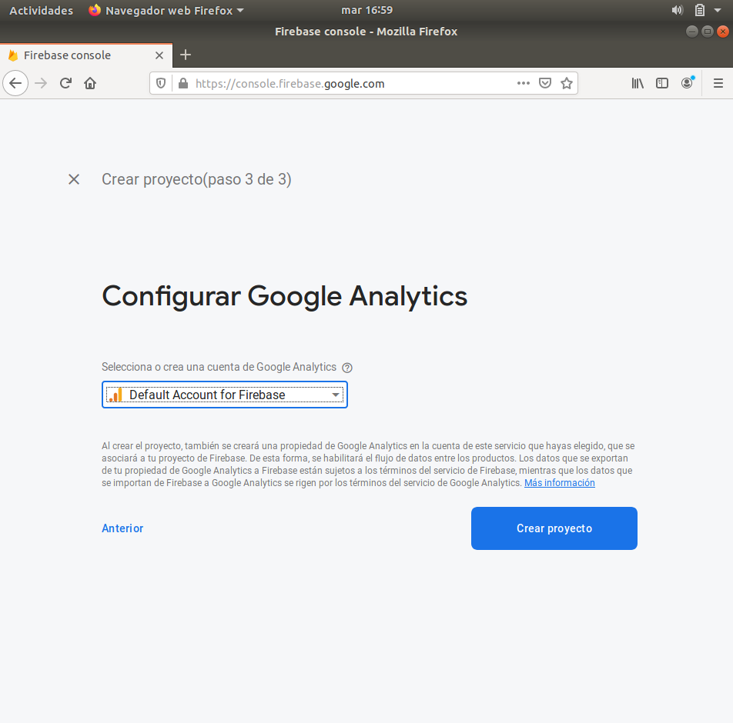

Fig. 6 - Configuring Google Analytics

* The project is already created. Click on ***Continuar***.

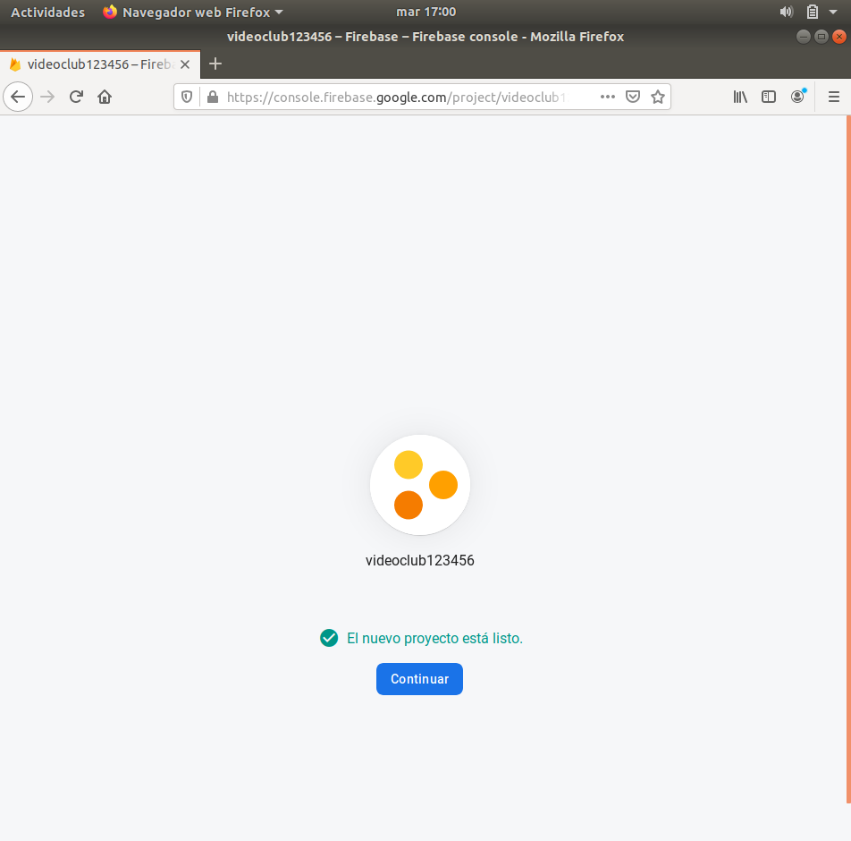

Fig. 7 - Finishing project creation

# **Configuration**

* To get started, we login in Firebase with a Google account with this command:

**firebase login**

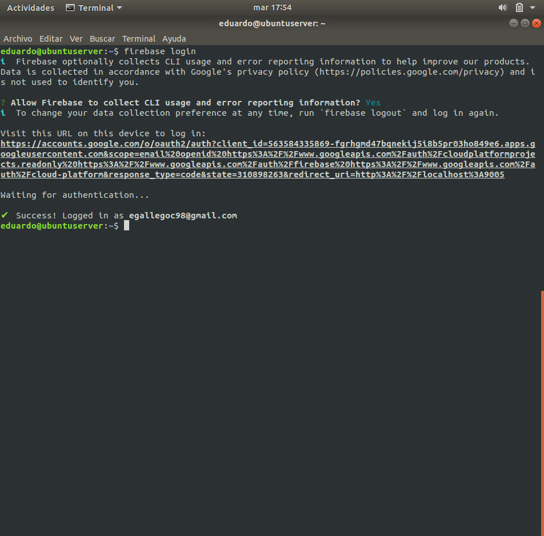

* Once you are logged, execute this command and select ***Database*** and ***Hosting*** for start to configure Firebase:

**firebase init**

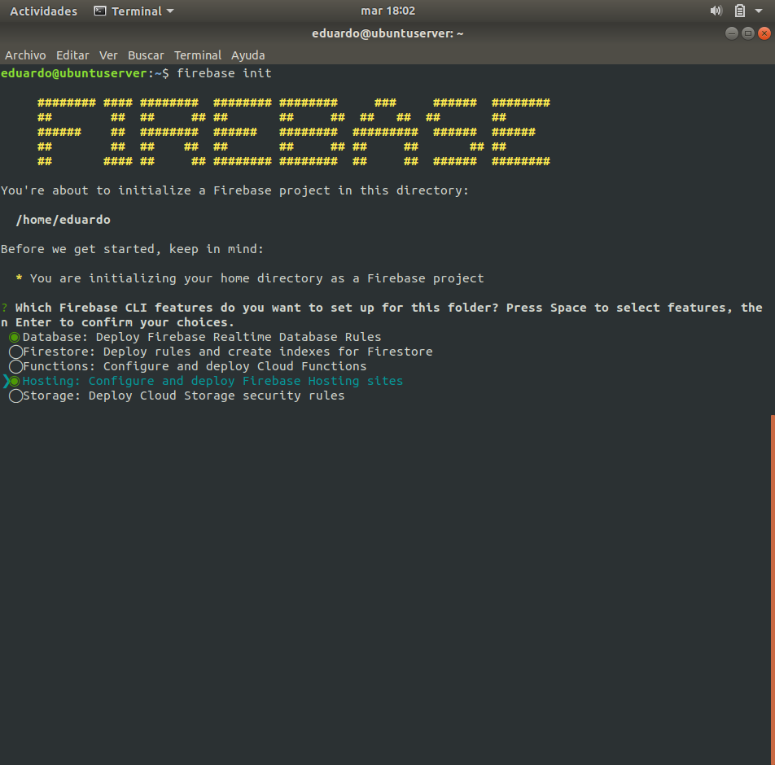

Fig. 8 - Firebase initialization

* The third step consists in answer all questions to realize the configuration.

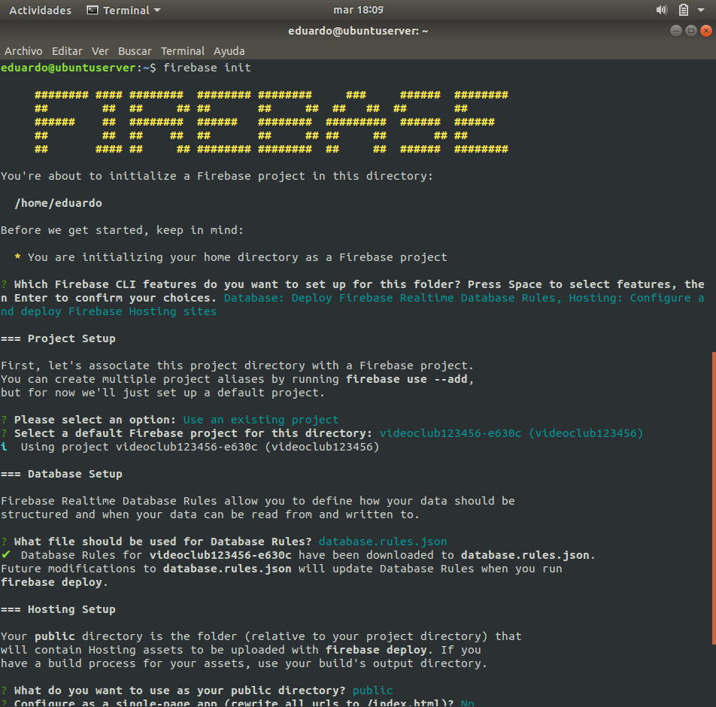

Fig. 9 - Questions I

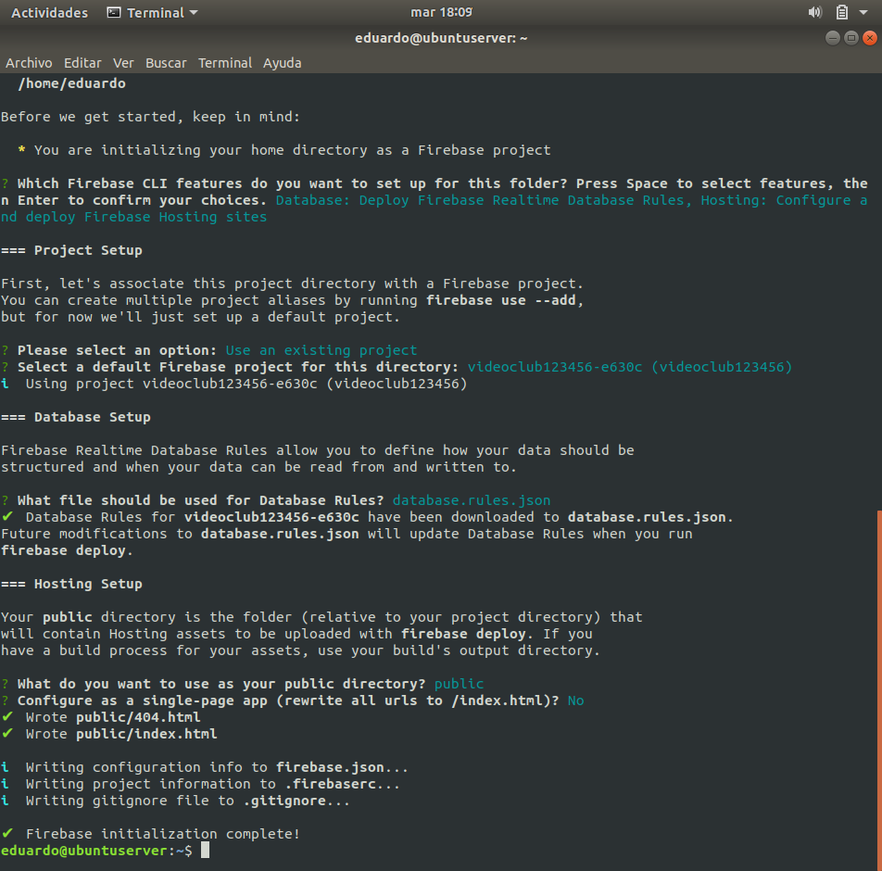

Fig. 10 - Questions II

# **Add project to a web application**

* We click the marked button for add the created project to a web application.



Fig. 11 - Project overview

* In this point, we give a nick to the application and click on ***Registrar aplicación*** button. The nick is private only for you.

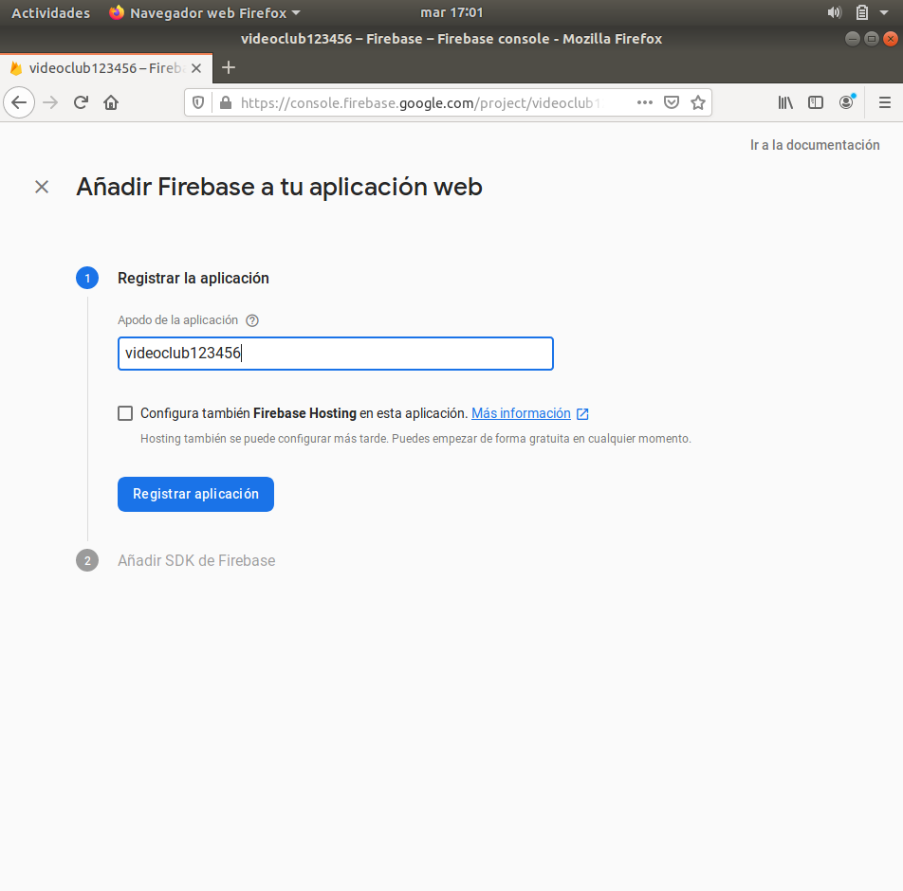

Fig. 12 - Adding project to a web application

* Next, we create a simple html file named ***holaMundo.html*** on the ***public*** directory of the Firebase server, that contains this code and click on ***Ir a la consola***.

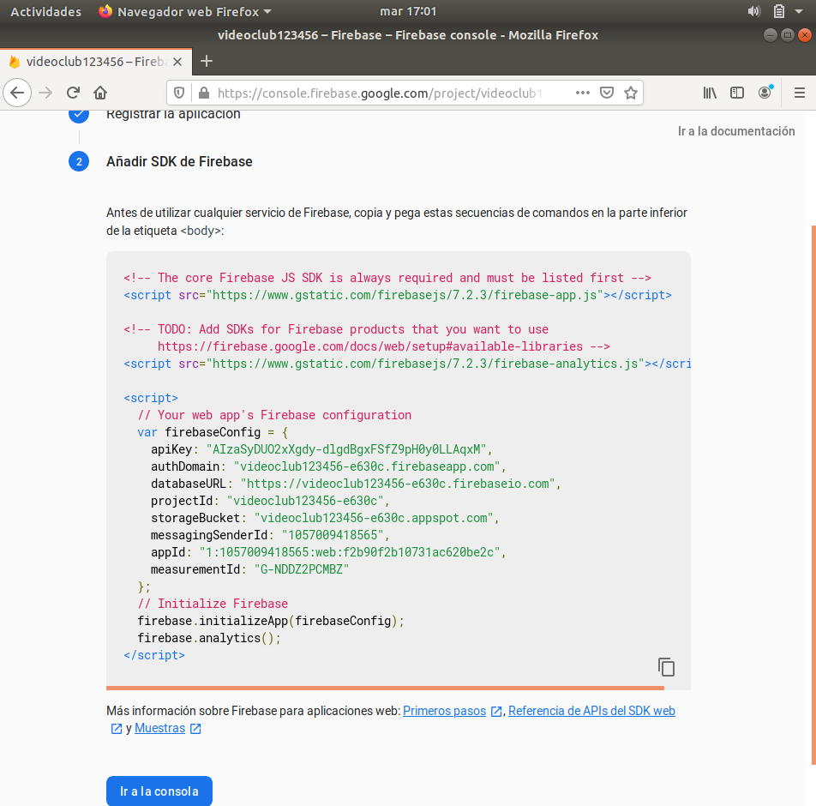

Fig. 13 - Firebase Project SDK

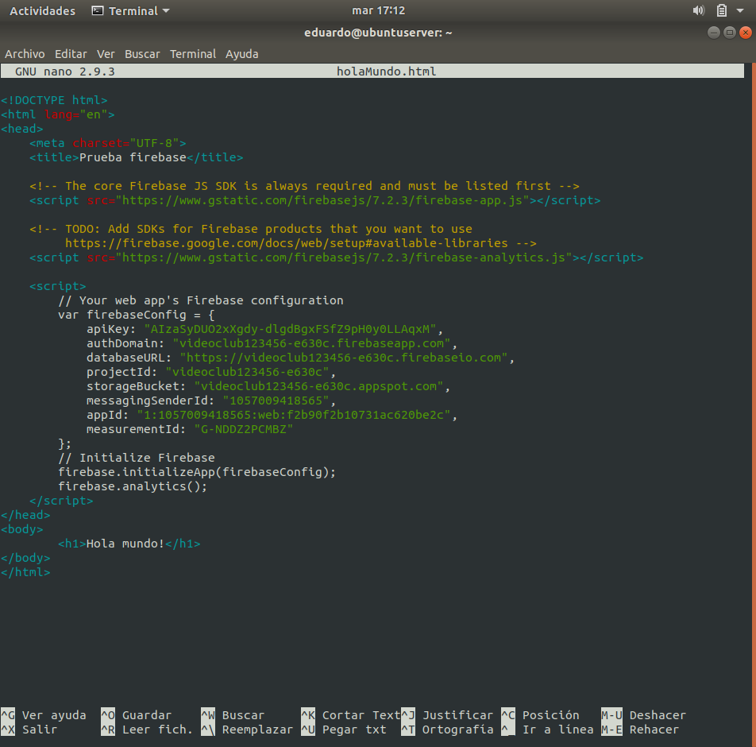

Fig. 14 - holaMundo.html

# **Database creation**

* For create a database on the project, we click on the ***Crear base de datos*** button.

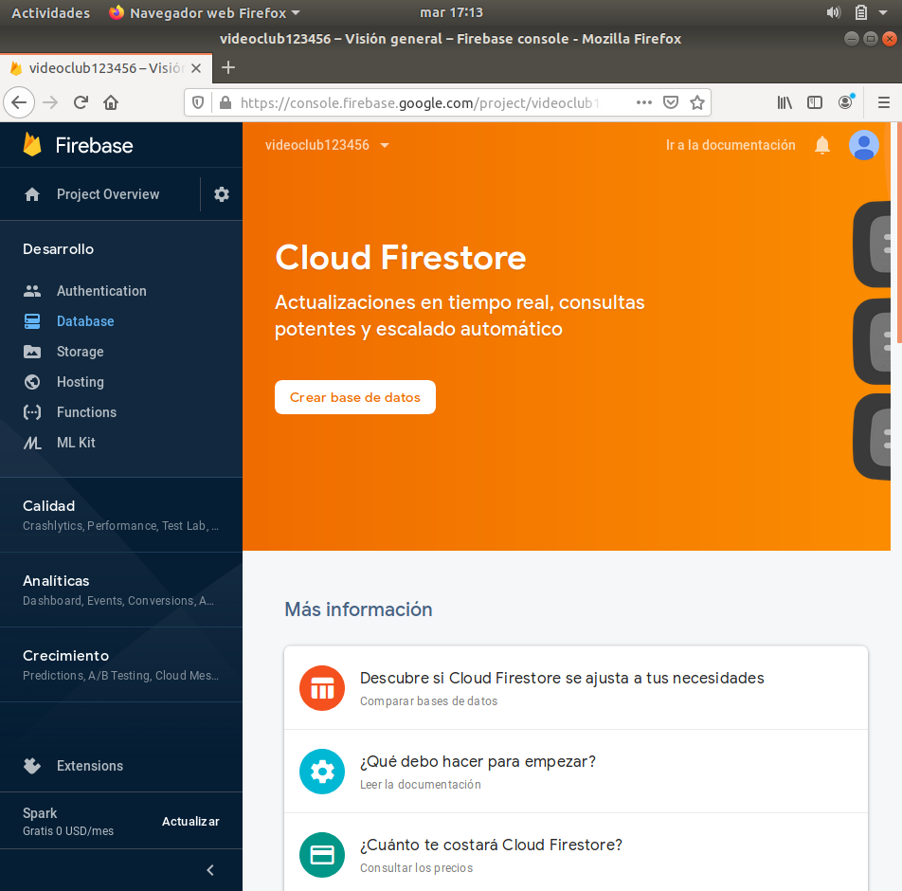

Fig. 15 - Database creation

* Here, we select the second option and click ***Siguiente***.

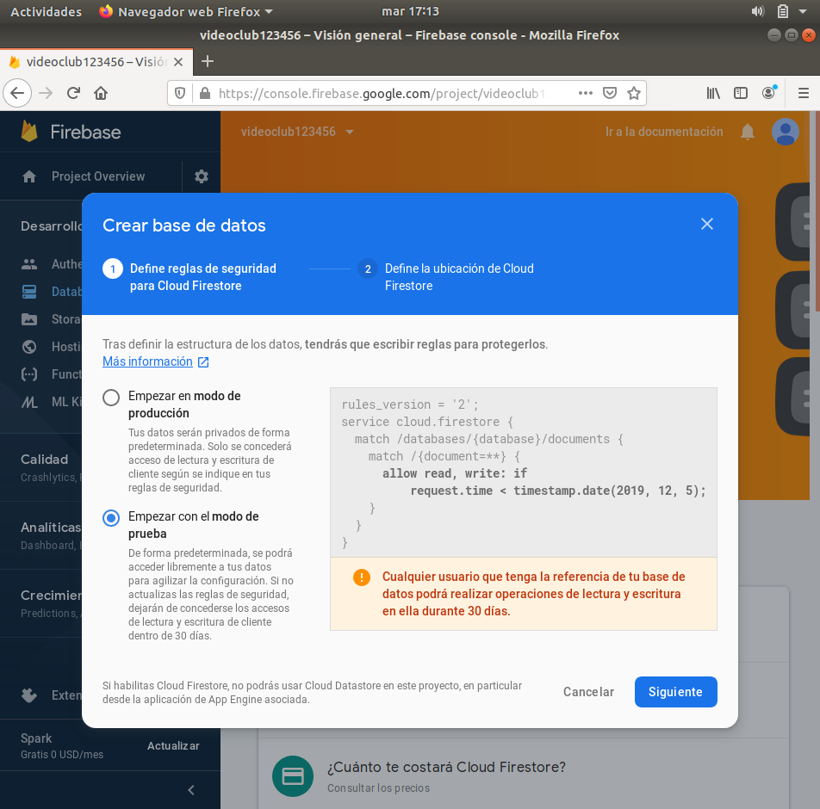

Fig. 16 - Database mode selectio

* Select ***eur3 (europe-west)*** option and click on the ***Listo*** button.

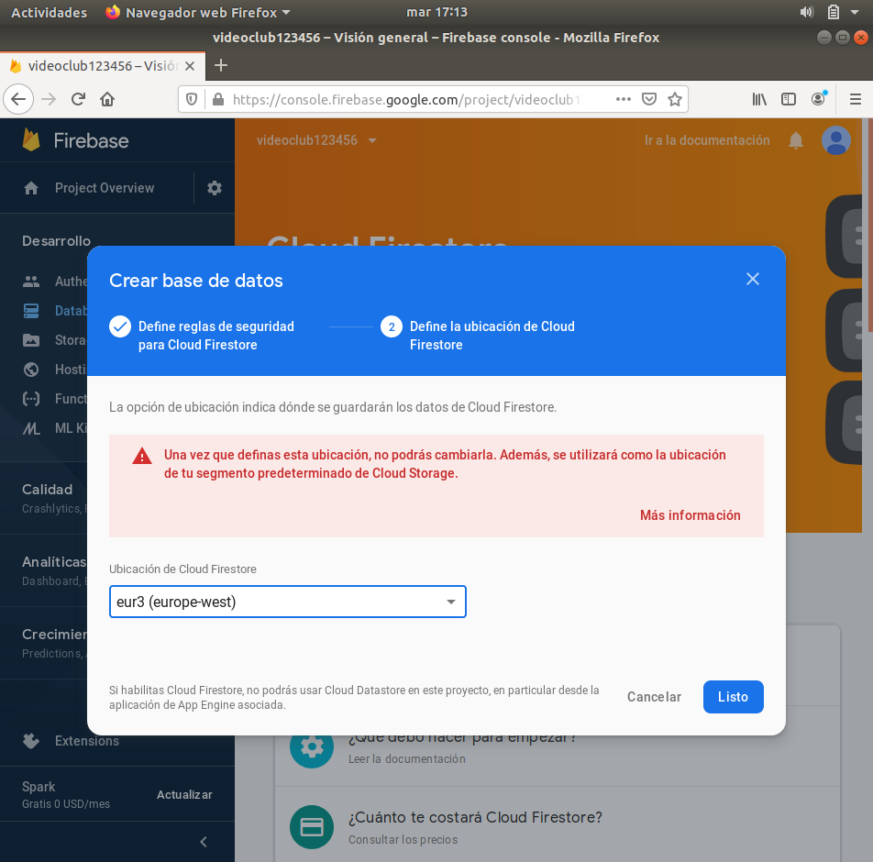

Fig. 17 - Database location selection

* Next, we select ***Realtime database*** and create a new child with name ***appName*** and value ***trabajador***, and click on ***Añadir***.

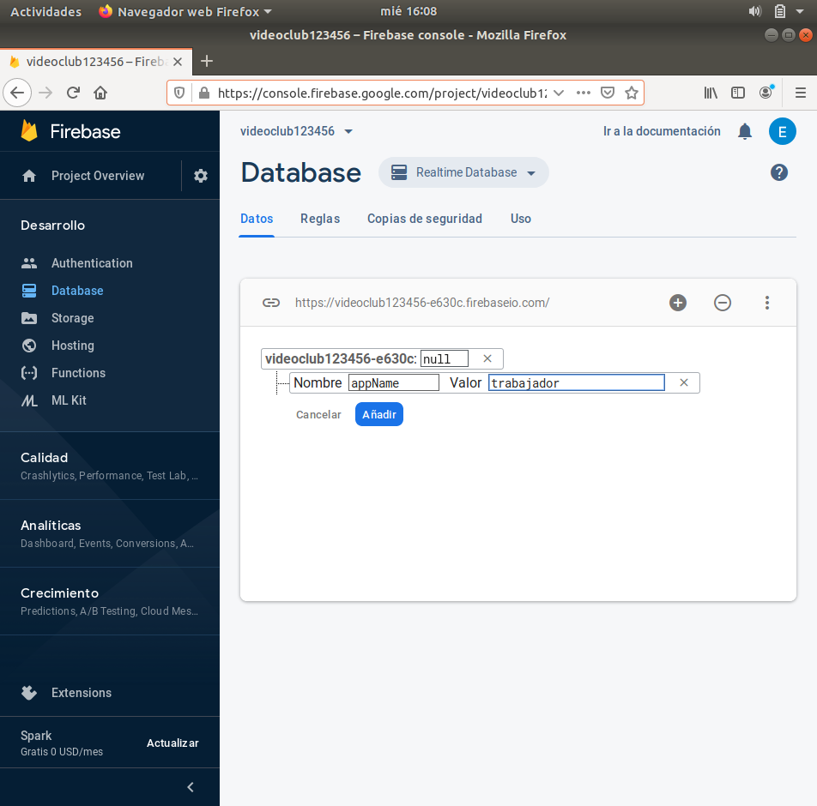

Fig. 18 - Creating a database chil

* Change rules on ***Reglas*** tab modifying ***.read*** and ***.write*** properties changing their value to true, and click on the ***Publicar*** button.

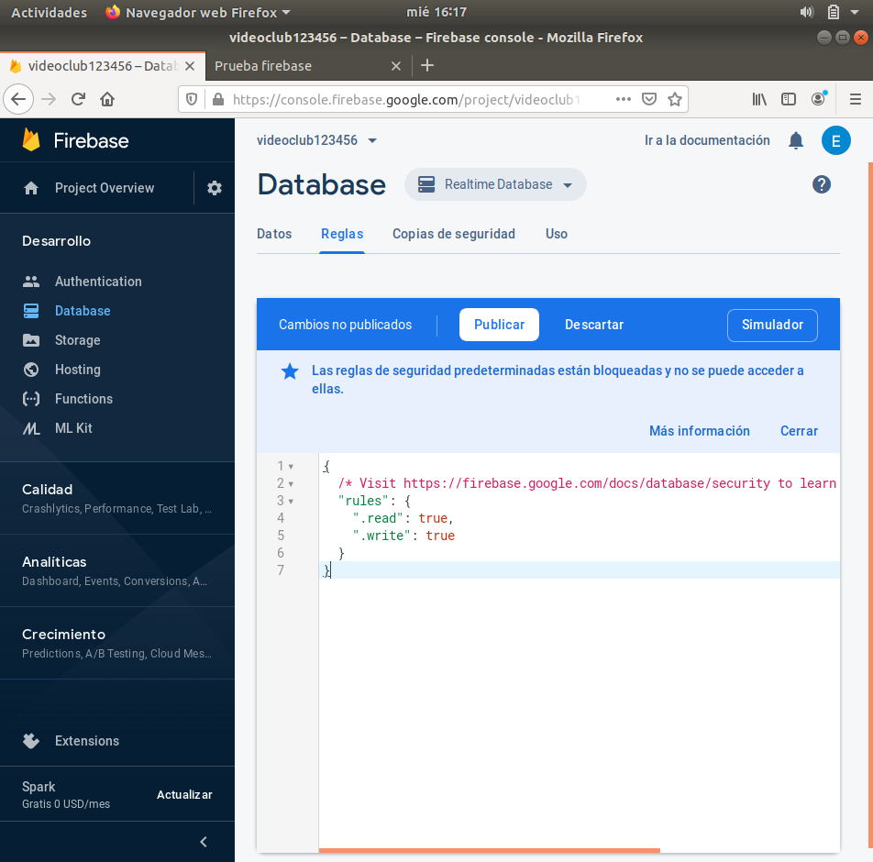

Fig. 19 - Allowing read and write on the database

* Add these lines on the html file recently created:

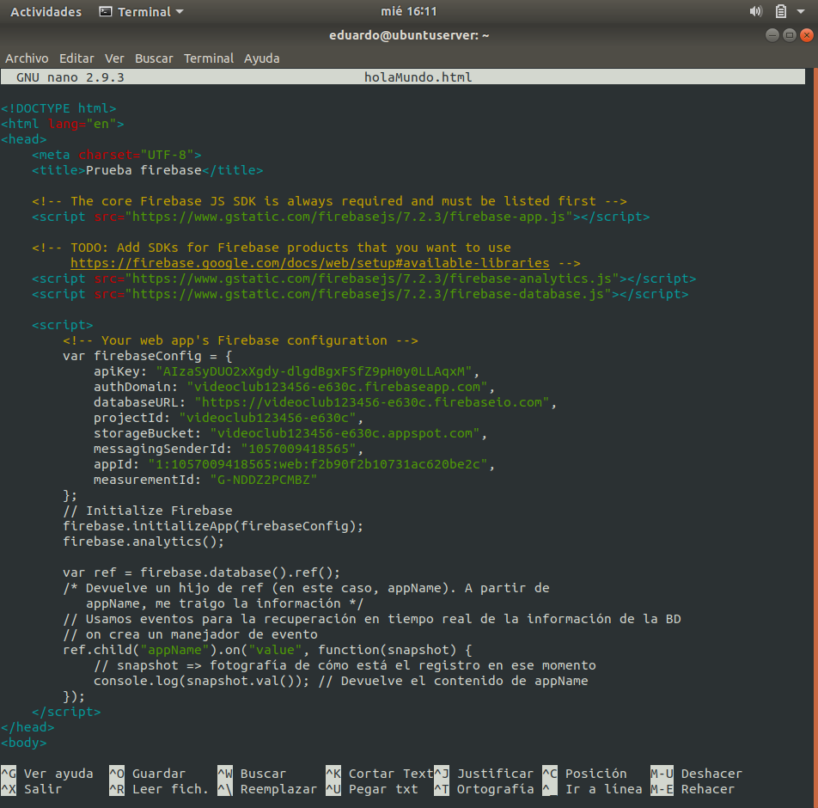

Fig. 20 - Lines for allow access to the database

# **Test performance**

Open the html file on a web browser for try if Firebase works.

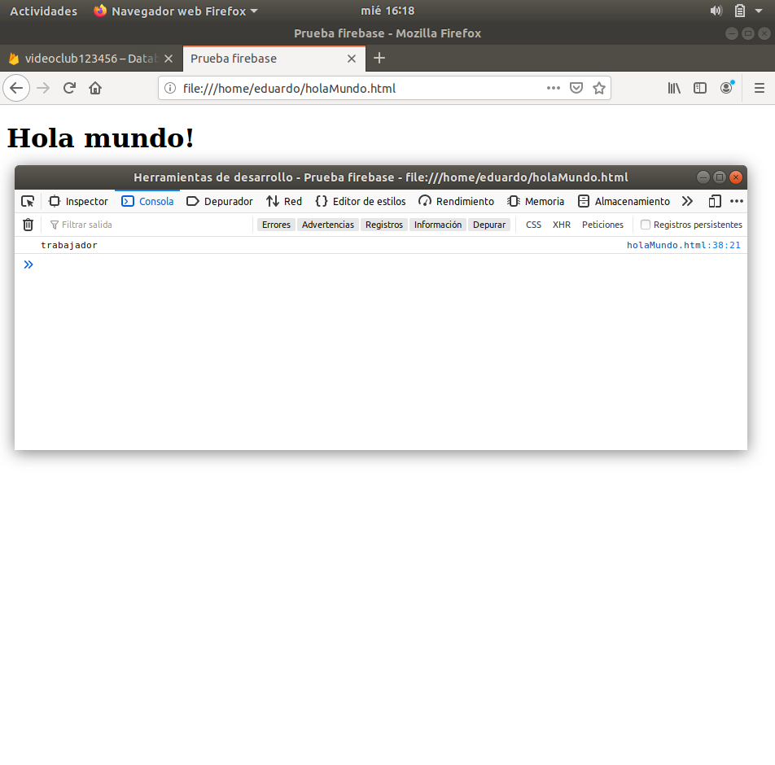

Fig. 21 - Testing if Firebase works

# **Start the server**

Finally, start the Firebase server with the following command:

***firebase serve***

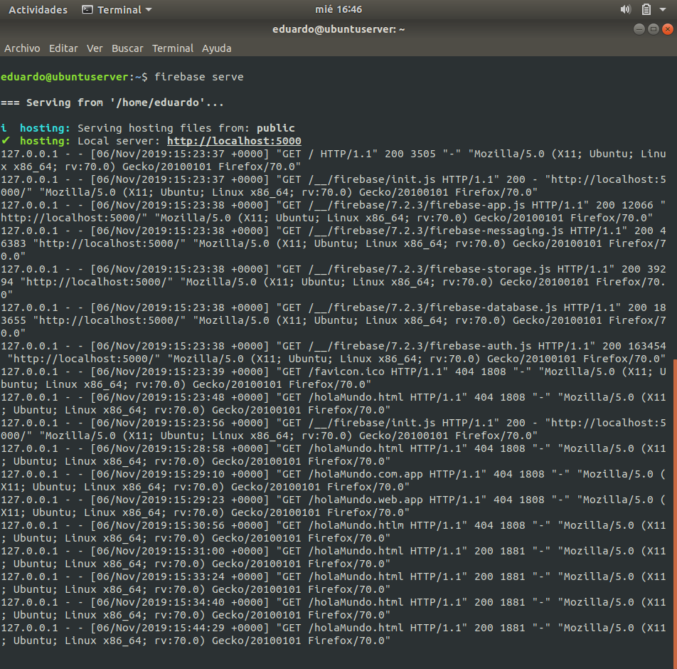

Fig. 22 - Firebase start